**Udacity Blockchain Developer Nanodegree**

**Project 1: Build Your Private Blockchain**

1. As per <https://knowledge.udacity.com/questions/45817>, block -> blockHash to differentiate between the requests
2. must use a GET call to request the Genesis block  
   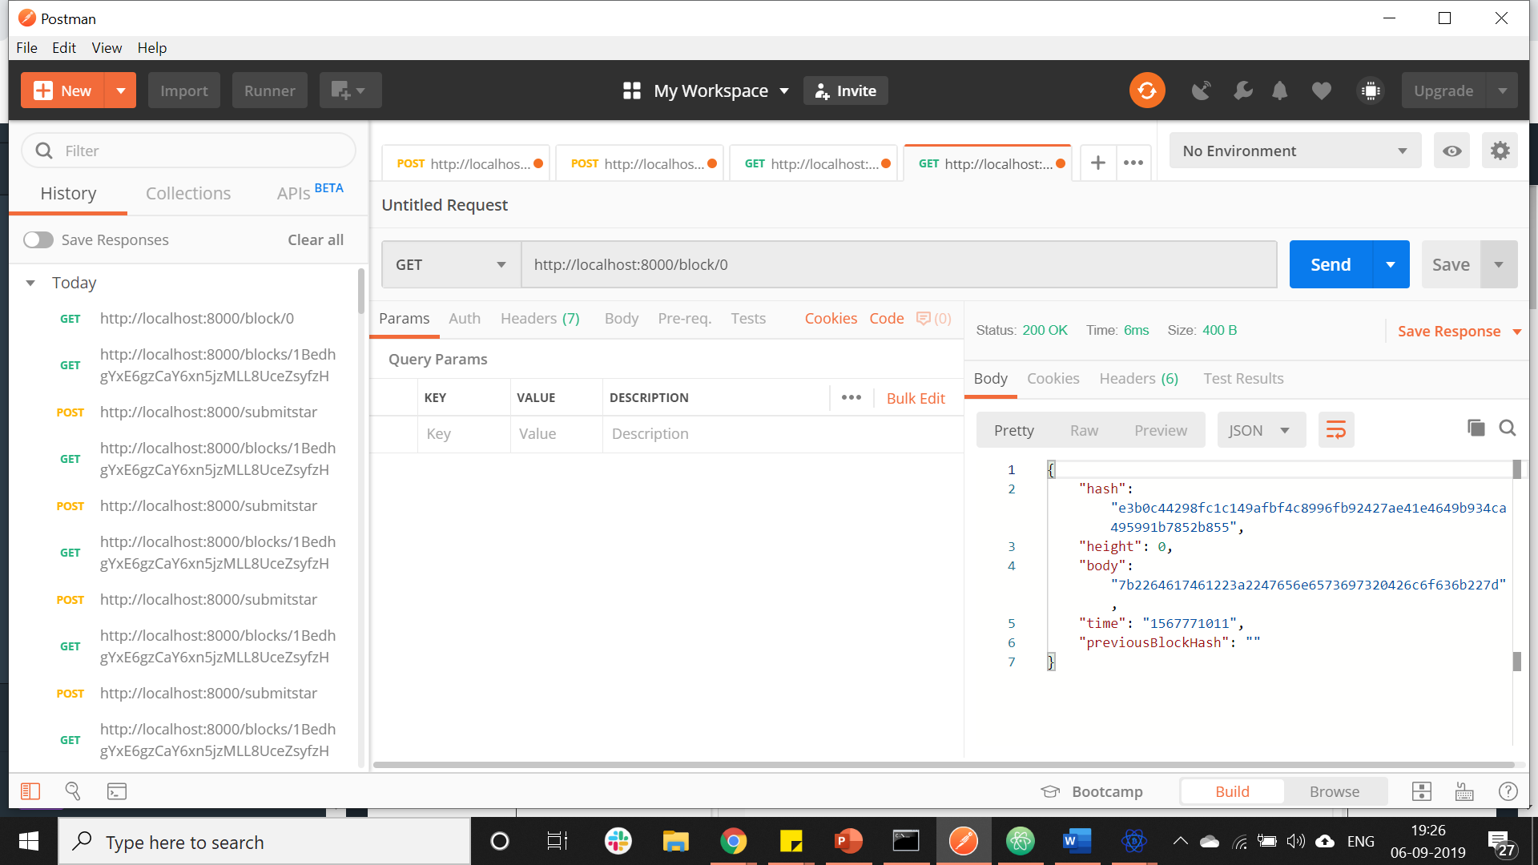
3. must use a POST call to requestValidation  
   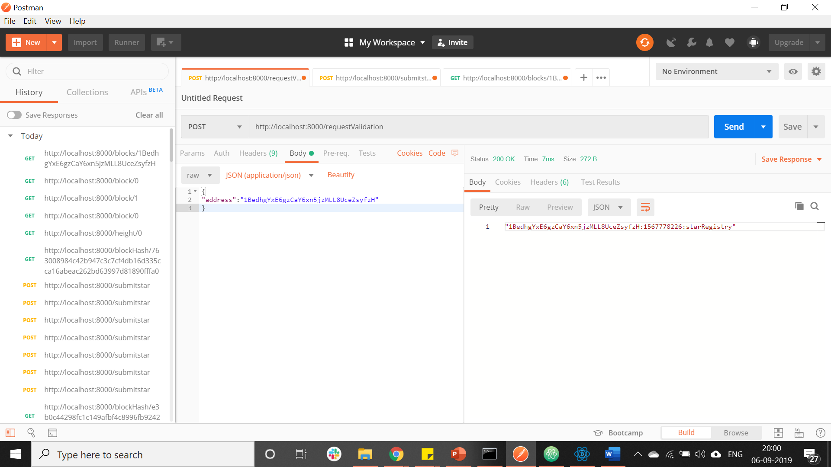
4. must sign message with your wallet  
   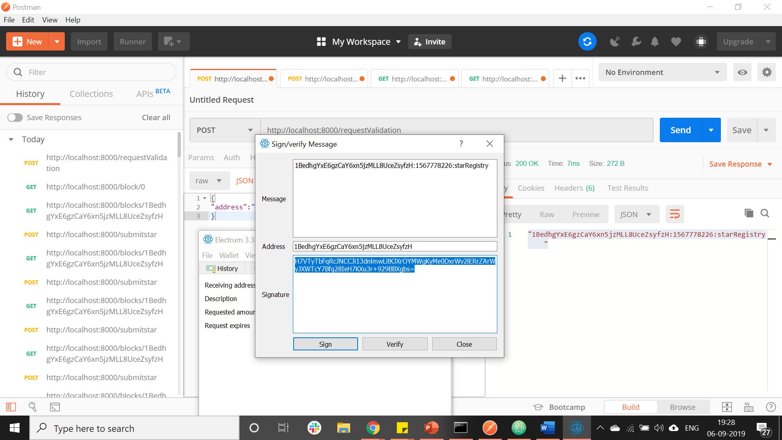  
   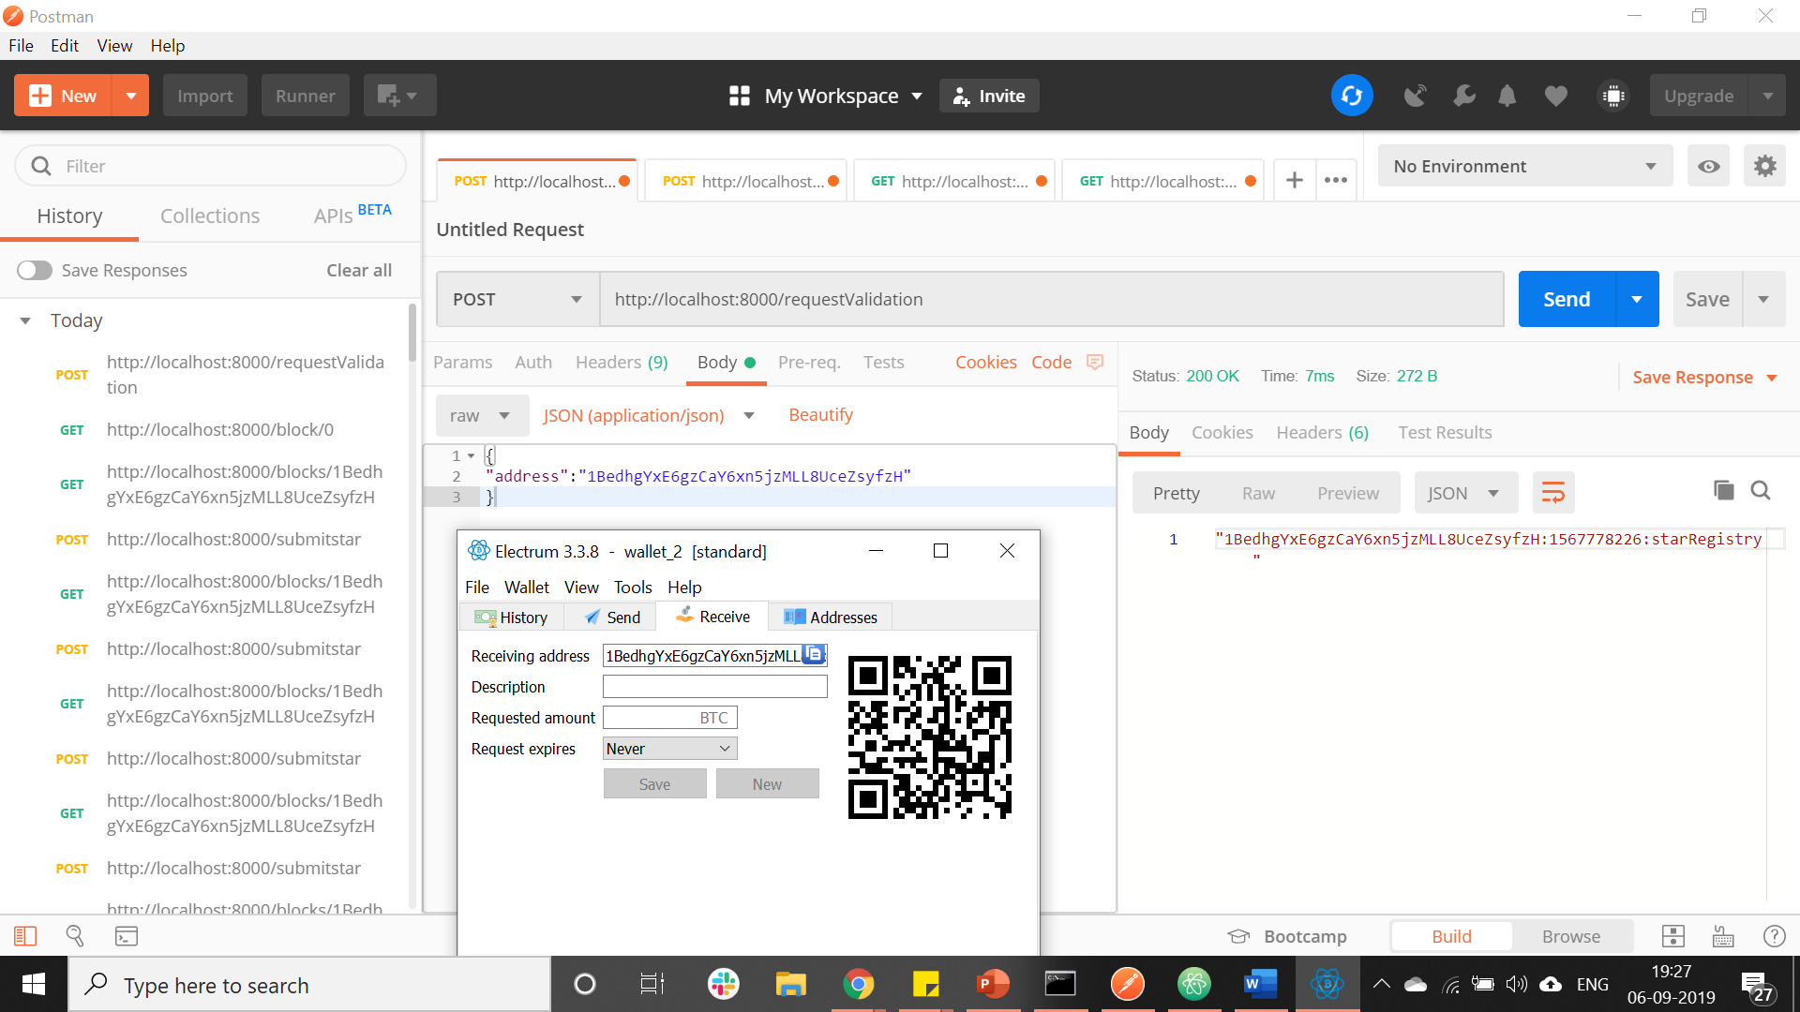
5. must submit your Star  
   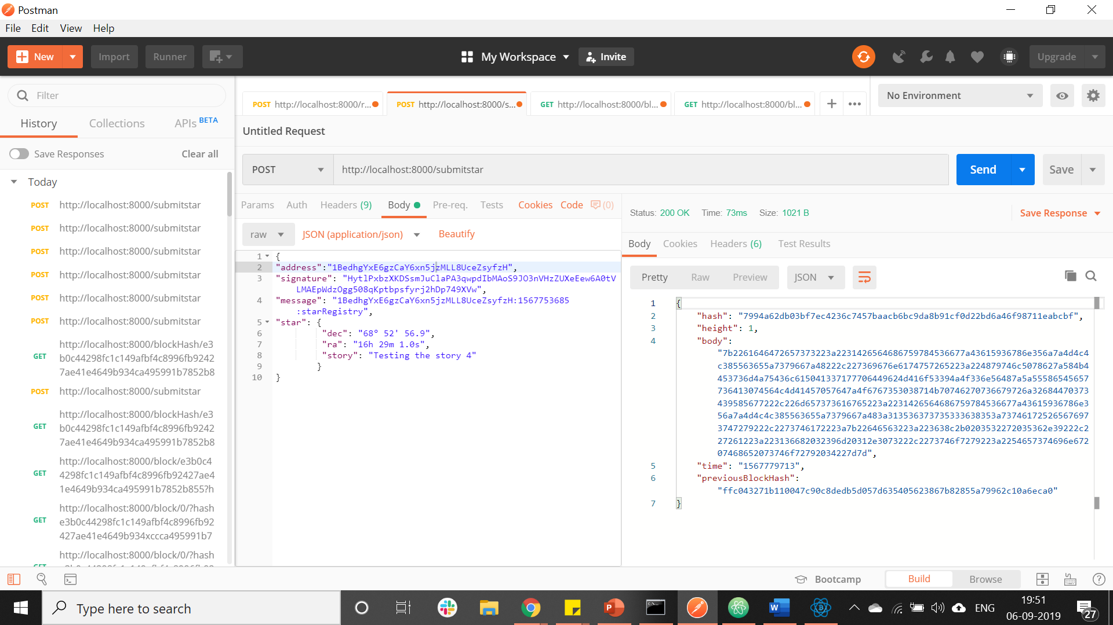
6. must use GET call to retrieve starts owned by a particular address  
   